Chapter 11, Problem 77.

What is the reading of the wattmeter in the network of Fig. 11.92?

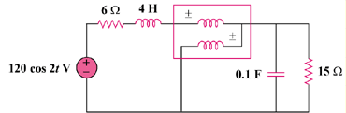

Figure 11.92
For Prob. 11.77.

